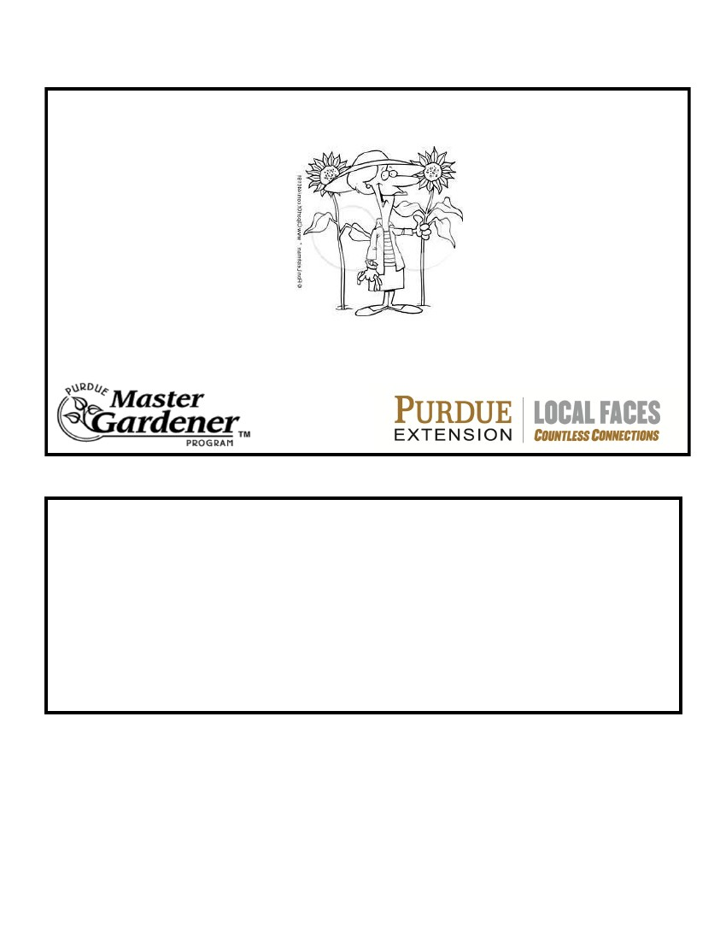
Non-Profit Reservation Form
GARDEN EXPO 2015
Presented by:
AND
Please return form to Dee Dilling, 5830 N 820 E., Attica, IN 47918 by April 1, 2015
Name of Organization:_______________________________________________
Name of Contact Person:_____________________________________________
Address:__________________________________________________________
__________________________________________________________
Phone number:_____________________________________________________
Email_____________________________________________________________
Please place a check mark in the appropriate space to indicate your needs.
_____6 ft table ______8 ft table ______chairs
Comments:
To be included in pre-event publicity, return the enclosed reservation form immediately.
Concessions will be available.

